**Міністерство освіти і науки, молоді та спорту**

**Національний технічний університет України**

**“Київський політехнічний інститут імені Ігоря Сікорського”**

Факультет ФІОТ

Кафедра ІП

**РЕФЕРАТ**

з дисципліни «Практичний курс англійської мови професійного спрямування. Частина 1»  
на тему: **“** **Introductions to eSports ”**

Виконав: Головня О.Р.

група ІП-11

Викладач: Бойко І. В.

Київ 2023

# CONTENTS

CONTENTS 2

INTRODUCTION 3

WHAT IS ESPORT 4

ESPORT IN THE WORLD 5

• General Overview of the History of Esports 5

• Growth and Globalization of Esports 5

• Economic Impact of Esports 6

• Social and Cultural Impact of Esports 7

• Esports and Education 7

• Health and Wellness in Esports 8

• Challenges and disputes 8

• Future Trends in Esports 9

• Conclusion: 9

SUMMARY 11

The Evolution of Esports: From Garage Competitions to Global Industry 11

SUMMARY TRANSLATION 12

Еволюція кіберспорту: Від Гаражних Змагань до Глобальної Індустрії 12

REFERENCES 13

GLOSSARY 14

# INTRODUCTION

In the modern world, the rise of esports, a term derived from "electronic sports," has raised a lot of interest and excited many people. This study takes a deep dive into the far-reaching effects of esports on a global level. With constant advancements in technology, gaming has crossed its traditional boundaries and came up as a major player in shaping contemporary society, from culture and economies to education.

As pixels multiplied, the world of gaming underwent an incredible transformation. Throughout the '80s arcade scene to the rise of online multiplayer, the gaming community continued to grow and explore new boundaries. Leading this evolution is esports, which has outdid simple fun to become a cultural phenomenon, revolutionizing how people engage with games, competition, and digital connection.

But the impact of esports extends far beyond the screens and into various industries. From revolutionizing technology and entertainment, to making its mark in fields like education and health, esports is breaking through traditional boundaries. As technology continues to advance at a rapid speed, esports remains at the forefront of innovation, shaping digital landscape.

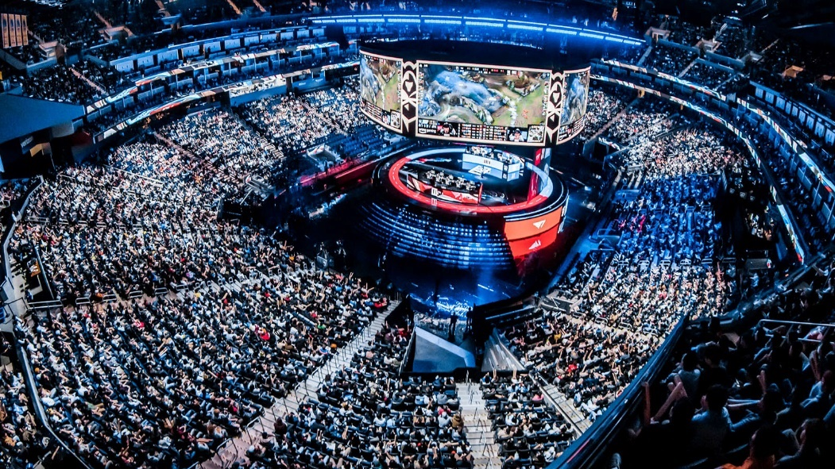

Illustration 1 - A packed hall at the 2023 League of Legends World Championship

Beyond the screens and keyboards, esports events have transformed into grand spectacles, filling arenas with roaring fans and breathtaking online audiences. The hype around tournaments such as The International and League of Legends World Championship mirrors the passion traditionally reserved for mainstream sporting events.

# WHAT IS ESPORT

Esports is a phenomenon that is rapidly gaining worldwide popularity and acceptance as a serious form of sport. The term "esports" comes from the combination of the words "cybernetics" and "sport", indicating that it is an activity that takes place in an electronic, virtual environment, but requires a high level of skill, strategic thinking and coordination from participants.

Esports has developed in its own unique way, starting as a hobby for video game players and evolving into a large-scale industry where professional players compete on a level playing field with athletes in traditional sports. This sport unites millions of fans and players around the world, creating its own culture and raising the standards of competition.

One of the main features of esports is the use of video games as a means of competition. All types of esports are based on different genres of video games, such as real-time strategy, shooters, fighting games, MOBAs (massively multiplayer online action games), and others. Professional players learn to master their chosen genre, optimize their skills, and learn game strategies to achieve maximum results.

Teamwork in esports is as important as individual skills. Many competitions are held in the format of teams, where each participant is responsible for their role in the game. Teams solve tactical problems, develop strategies, and work together to achieve victory.

# ESPORT IN THE WORLD

* General Overview of the History of Esports

The history of esports is a wonderful journey from the beginnings of video games to becoming a major industry. Esports started out in small garages where enthusiasts competed in arcade games, but with the development of technology, it has grown into a large industry. Illustrations from the first tournaments and consoles used in the 70s and 80s remind us of the modesty and yet incredibility of those times.

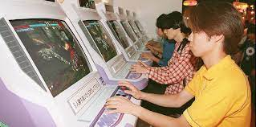

Illustration 2 - A display of video game consoles and arcades that were popular in the early days of esports.

* Growth and Globalization of Esports

Over the past few decades, esports has undergone a significant evolution, moving beyond local tournaments to become a global phenomenon with international competitions of a huge global scale. Today, these events bring together players from all over the world, creating a special intercultural environment. This melting pot of talent and perspectives not only fuels the competitive spirit, but also helps build the esports community. This phase of globalization marks a transformative stage in the history of esports, as borders are blurred and a shared love of gaming brings people together from all corners of the world.

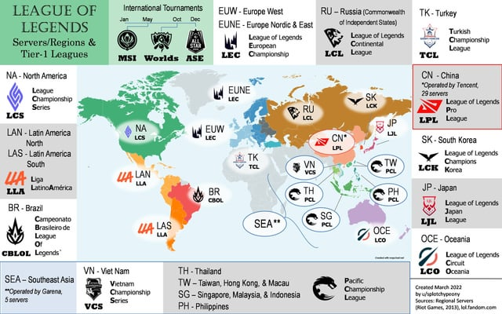

Illustration 3 - A world map showing the locations of major esports events from the game League of Legends.

* Economic Impact of Esports

The economic importance of esports is becoming increasingly obvious, as demonstrated by the growth of prize pools and significant investments in infrastructure. Global companies are allocating resources to key aspects such as team building, player development, and tournament broadcasting. This surge mirrors the growing realization of the potential of the esports industry.

Tracking the trajectory of the industry's economic success becomes easier when analyzing graphs and charts. The capital injection into various aspects of esports not only underscores its economic importance, but also pushes the industry into a strong and dynamic era, promoting innovation, talent development, and the continued expansion of its global reach..

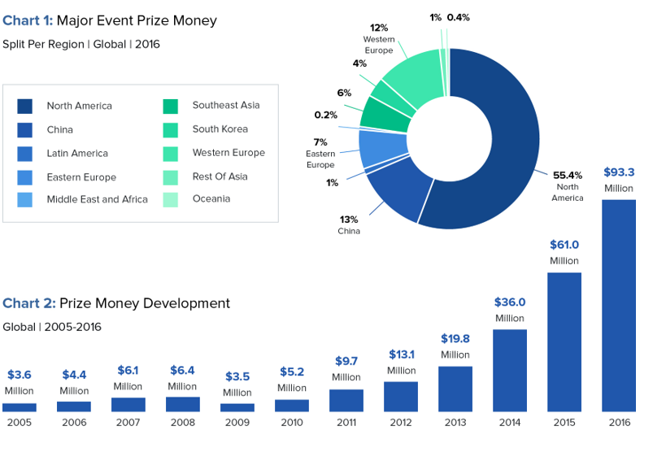

Illustration 4 - Graphs showing the growth dynamics of prize pools and investments in esports in recent years.

* Social and Cultural Impact of Esports

The esports community creates its own cultural space. Fans become part of a large online community where they discuss and share their impressions of the game. It also contributes to the formation of new traditions, holidays, and rituals.

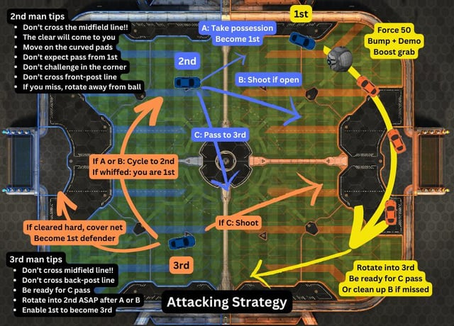

Illustration 5 - Screenshot from forums and chats of players discussing game strategies and joint events.

* Esports and Education

The development of educational programs related to esports opens up new perspectives for young talents. Training programs cover not only aspects of the game, but also analytics, training, and management, which prepares young people for a professional challenge in this field.

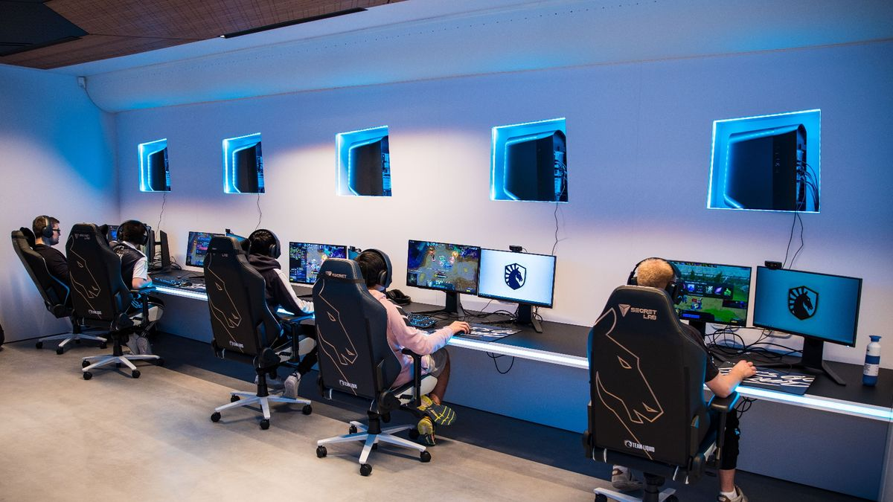

Illustration 6 - Image of training programs aimed at developing players.

* Health and Wellness in Esports

Esports is undergoing significant changes as physical and mental health issues come to the forefront. Recognizing the importance of players' physical and mental health, training, fitness programs, and psychological support are becoming necessary components for esports players. The need is not only to improve performance, but also to ensure all-round development that contributes to the longevity of their careers. The development prioritizes the well-being of its players, opening an era in which health and wellness are necessary pillars in the pursuit of excellence in competitive esports.



Illustration 7 - Demonstration of exercise routines of the Faze Clan esports team.

* Challenges and disputes

The controversies and challenges in esports cover a range of issues, from worries about fraud to the complex dynamics of prize money distribution and ethical standards. Overcoming these complexities requires active and continuous debate combined with responsible decision-making. These discussions are becoming more and more important in shaping the trajectory of esports with a clear focus on creating a fair and equal environment.

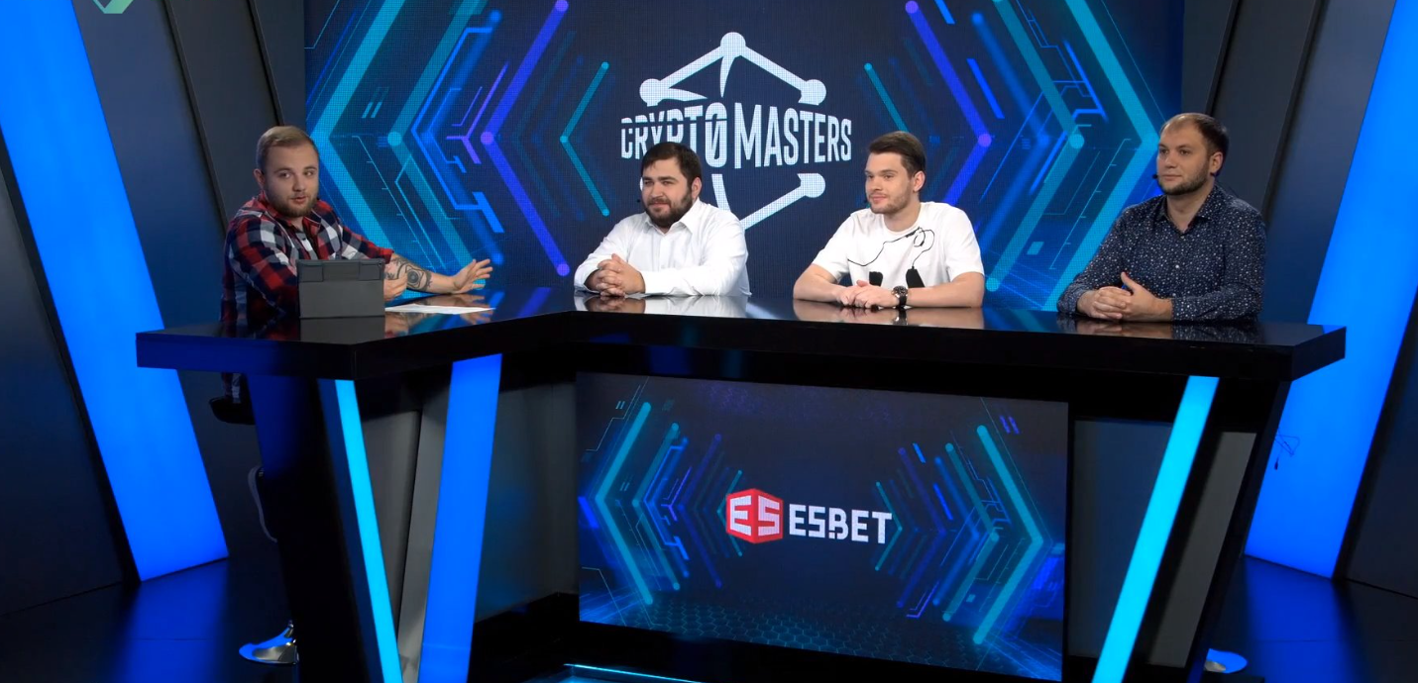

Illustration 8 - Public discussions on controversial issues in esports.

* Future Trends in Esports

The trajectory of esports development is preparing for an exciting journey marked by constant innovation. The rise of advanced technologies, the evolution of increasingly effective tournament structures, and the introduction of new game formats will bring the esports industry to a new level of development and improvement. The competitive gaming landscape is ready for a dynamic transformation as these advances open up a new era of opportunities and engagement in the esports ecosystem.

* Conclusion:

Esports has taken over not only the virtual arenas of players, but also all spheres of our society, establishing itself as a powerful catalyst for change. On the background of economic prosperity, this industry has been able to attract significant investments and promote infrastructure development. The growth of prize pools and large-scale investments are building the foundation for esports' success, making it a key player in the global economy.

However, the impact of esports is not limited to numbers and finances. It has become a true meeting place for different cultures and nationalities at international tournaments, contributing to the globalization of not only the game, but also ideas and values. Esports opens the door to cultural variety and community, creating an international platform for the exchange of experiences and traditions.

In the digital era, where technology determines the course of development, esports not only adapts to changes but also determines their course. Its influence on shaping the future is becoming an important part of our modern lifestyle. The fantastic growth in popularity and recognition of esports confirms its status not only as an entertainment form, but also as an important factor in determining the direction of society.

Therefore, esports is not just a game - it is an innovative force that fills our environment with new ideas, changes the economy and culture, and determines the future where the boundaries between the virtual and real worlds are blurred.

# SUMMARY

# The Evolution of Esports: From Garage Competitions to Global Industry

Initially, esports started with small garages where enthusiasts competed in arcade games, but with the development of technology, it grew into a large industry. Thus, esports became a full-fledged industry.

The growth in popularity of esports was not long in coming. International tournaments and leagues are becoming a place for different cultures and players to clash. The globalization of esports is taking place, opening the door to new faces and promoting cultural diversity in the industry.

And the impact of esports on the economy is obvious, as we are seeing an increase in prize pools and investments in infrastructure. Companies from all over the world are investing in team building, player development, and tournament broadcasting. There is also an immediate impact on the esports community, which is creating its own cultural space. Fans become part of a large online community where they discuss and share their impressions of the game. This also contributes to the formation of new traditions, holidays, and rituals.

It is clear that the future of esports is full of innovations. The development of new technologies, more effective tournaments, and new game formats are expanding the industry.

The impact on the world is huge. Esports has become a global force that cannot be ignored. As society continues to enter the digital age, esports will play an increasingly influential role in shaping the future.

# SUMMARY TRANSLATION

# Еволюція кіберспорту: Від Гаражних Змагань до Глобальної Індустрії

Початково кіберспорт існував в малих гаражах, де ентузіасти змагалися в аркадних іграх, але з розвитком технологій він переріс у велику індустрію. Так кіберспорт став повноцінною галузю.

Зростання популярності кіберспорту не залишилось чекати довго. Міжнародні турніри та ліги стають майданчиком для зіткнення різних культур та гравців. Відбувається глобалізація кіберспорту, що відкриває двері для нових облич та сприяє культурній різноманітності у цій галузі.

Вплив кіберспорту на економіку є очевидним, адже ми спостерігаємо зростання призових фондів та інвестицій в інфраструктуру. Компанії з усього світу вкладають кошти в створення команд, розвиток гравців та трансляцію турнірів. Невідкладний вплив є і на спільноту кіберспорту, що створює свій власний культурний простір. Фанати стають частиною великої онлайн-спільноти, де вони обговорюють та діляться враженнями від гри. Це також сприяє формуванню нових традицій, свят та обрядів.

З впевненістю можна сказати, що Майбутнє кіберспорту наповнене інноваціями. Розробка нових технологій, ефективніші турніри та нові формати гри розширяють галузь.

Вплив на світ є величезним. Кіберспорт став глобальною силою, яку неможливо ігнорувати. Оскільки суспільство продовжує входити в епоху цифрових технологій, кіберспорт відіграватиме все більш впливову роль у формуванні майбутнього.

# REFERENCES

1. Esports [Електронний ресурс] – Режим доступу <https://en.wikipedia.org/wiki/Esports>

2. Esports: A Guide to Competitive Video Gaming [Електронний ресурс] – Режим доступу <https://www.toptal.com/finance/market-research-analysts/esports>

3. Hamari, J., Sjöblom, M., & Törhönen, M. (2016). Explaining the equalization phenomenon in digital games: The role of skilled players. Journal of Computer-Mediated Communication, 21(1), 50-65.

4. How Much Is the Gaming Industry Worth in 2021? [+25 Powerful Stats] [Електронний ресурс] – Режим доступу <https://techjury.net/blog/gaming-industry-worth/#gref>

5. Lopez-Gonzalez, H., & Griffiths, M. D. (2020). The problematic use of social networking sites is more than just gaming disorder: A brief commentary on Billieux et al. (2020). Journal of Behavioral Addictions, 9(2), 246-247.

6. LoL Major Events [Електронний ресурс] – Режим доступу <https://www.reddit.com/r/leagueoflegends/comments/tfrla0/started_watching_esports_this_year_and_made_a_map/>

7. Taylor, T. L. (2018). Watch me play: Twitch and the rise of game live streaming. Princeton University Press.

# GLOSSARY

1. Esports: A term derived from "electronic sports," referring to competitive video gaming.
2. Arcade Games: Coin-operated entertainment machines often found in public spaces, popular in the early days of esports.
3. Tournaments: Organized competitions where players or teams compete against each other, a central element in esports.
4. Globalization: The process of esports expanding from local to international scale, involving players from around the world.
5. Prize Pools: The total monetary rewards offered in esports competitions.
6. Infrastructure: The underlying facilities and systems supporting esports events and organizations.
7. Cultural Space: The unique environment and community created by esports enthusiasts.
8. Cross-cultural Environment: The diverse cultural interactions fostered by international esports competitions.
9. Investments: Financial contributions made by companies in areas like team building and tournament broadcasting.
10. Digital Connection: The interconnectedness facilitated by esports in the digital era.
11. Technological Advancements: Innovations contributing to the evolution of esports.
12. League of Legends World Championship: A prominent esports tournament for the game League of Legends.
13. Controversies: Disputes and disagreements within the esports community.
14. Ethical Standards: Shared principles governing fair play and conduct in esports.
15. Digital Landscape: The overall online environment influenced by esports and gaming.
16. Faze Clan: A well-known esports team.
17. Future Trends: Anticipated developments and changes in the esports industry.
18. Digital Age: The contemporary era characterized by widespread use of digital technology.
19. Education Programs: Initiatives preparing individuals for careers in esports through training and development.
20. Fitness and Wellness: The focus on physical and mental health in esports.
21. Innovation: Introduction of new ideas, technologies, and formats in esports.
22. Mainstream Sporting Events: Traditional sports competitions that esports events are gaining popularity comparable to.
23. LoL: League of Legends (LoL), commonly referred to as League, is a 2009 multiplayer online battle arena video game developed and published by Riot Games.
24. Hype: Excitement and enthusiasm surrounding esports events.
25. Moderation: Maintaining balance and fairness in the esports community.
26. Gaming Community: The collective of individuals engaged in video gaming and esports.
27. Traditional Boundaries: Conventional limits and expectations in the world of gaming.
28. Social Impact: Influence on societal norms, traditions, and interactions by esports.
29. Communication Platforms: Forums, chats, and other mediums facilitating discussions within the esports community.
30. Health Issues: Physical and mental challenges faced by esports professionals.
31. Fair and Equitable Environment: Ensuring just and unbiased conditions in esports.
32. Digital Transformation: The profound changes brought about by technology in various sectors, including esports.
33. Illustrations: Visual representations supporting the narrative in the study.
34. Team Development: Building and enhancing the capabilities of esports teams.
35. Player Development: Training and nurturing the skills of esports players.
36. Screen: Reference to computer or gaming screens in the context of esports.
37. Rituals: Established customs and practices within the esports community.
38. Traditions: Long-standing practices and customs within the esports culture.
39. Holidays: Celebratory occasions within the esports community.
40. Rapid Speed: Swift and accelerated pace, referencing the quick advancement of technology.
41. Online Multiplayer: Gaming mode where players compete or collaborate over the internet.
42. Digital Age: The era marked by widespread use of digital technology.
43. Modesty: Humble and unassuming nature, referring to the early days of esports.
44. Garages: Initial locations where early esports enthusiasts gathered to compete.
45. Spectacles: Grand and impressive displays, referring to esports events.
46. Roaring Fans: Enthusiastic and loud supporters at esports events.
47. Breathtaking Audience: A captivating and awe-inspiring online viewership of esports events.
48. Passion: Intense enthusiasm and dedication, akin to mainstream sports.
49. Cheating: Unethical practices compromising the integrity of esports competitions.
50. Digital Age: The contemporary era marked by widespread use of digital technology.
51. New Perspectives: Fresh opportunities and outlooks provided by esports-related educational programs.
52. Analytics: Examination and interpretation of data in esports, beyond just playing the game.
53. Management: Organizational and strategic aspects of esports, beyond playing.
54. Balanced Development: Ensuring holistic growth, both physically and mentally, for esports professionals.
55. Longevity: Prolonged and sustainable careers in the esports industry.
56. Decision-Making: The process of making choices and reaching conclusions, vital for addressing esports challenges.
57. Innovation: Introduction of new ideas, technologies, and formats in esports.
58. New Game Formats: Evolving structures and modes of esports competitions.
59. Impact on the World: Far-reaching influence of esports on global society and various sectors.
60. Digital Transformation: Profound changes brought about by technology, prominently seen in esports.
61. Economic Prosperity: Positive financial outcomes associated with the growth of esports.
62. Cultural Transformation: Shifts in societal norms and behaviors influenced by esports.
63. Global Force: A powerful and influential presence on a worldwide scale.
64. Mainstream Sports: Traditional sports that esports is gaining recognition alongside.
65. Interactive Map: Visual representation of esports event locations on a world map.
66. Discussions: Conversations and debates within the esports community.
67. Industry's Financial Success: Positive outcomes and growth in the financial aspects of the esports sector.
68. Graphs and Charts: Visual representations illustrating trends and patterns in esports economics.
69. Responsibility: Being accountable for ethical conduct and decisions in esports.
70. Shaping the Future: Influencing the trajectory and development of global society through esports.